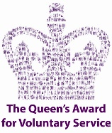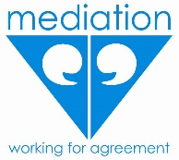
WEST SUSSEX MEDIATION SERVICE
(Charity No: 1084592)
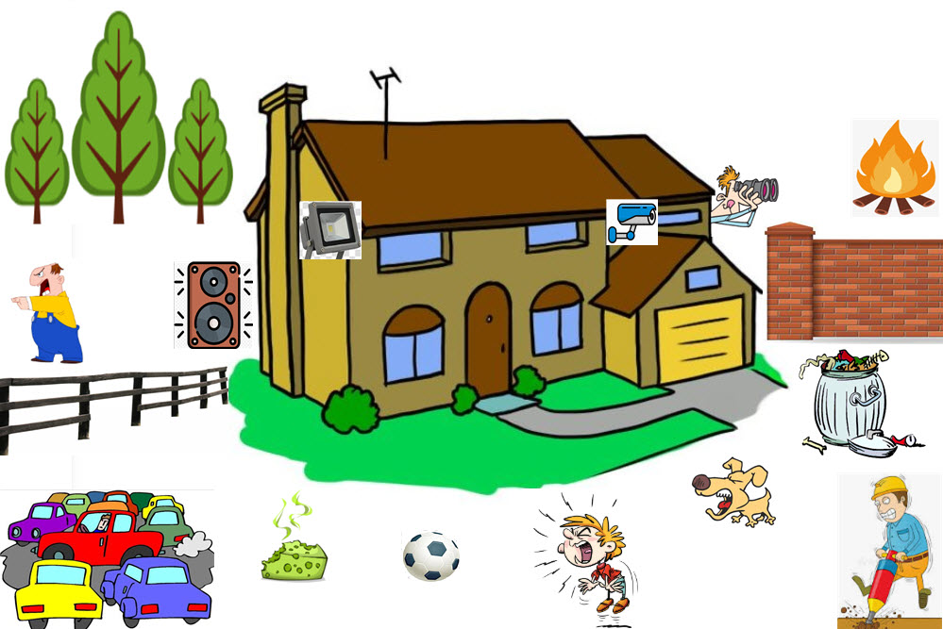
We specialise in resolving
CONFLICTS IN THE COMMUNITY through FREE MEDIATION
- Neighbour Disputes and Conflicts within Families
GRAND RAFFLE
Tickets £1 Each
Great Prizes – Follow this QR CODE for full list
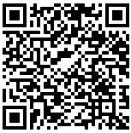
Draw - 9pm on Friday 18th November 2022 at The Capital Theatre, Horsham

Web: www.wsms.org.uk Tel: 0300 200 0025 Email: info@wsms.org.uk

